**Earn-to-Play: NFT Gaming Industry**

Although the global gaming business is still expanding in all regions, its current design favors game producers over players and promotes a one-way value chain in which players pay access to in-game resources and game play possibilities through payment. The usefulness and value of in-game purchases and asset acquisitions are more efficiently captured by players thanks to blockchain-based games and decentralized apps (dApps).

Non-fungible tokens (NFTs), which are digital assets that stand in for in-game content, are what make blockchain technology in gaming possible. The blockchain networks that support NFTs provide player ownership, and proved scarcity, interoperability, and immutability, while these tokens are one-of-a-kind, uncommon, and indivisible. These benefits might encourage widespread adoption and a far more equal value model when taken together.

**The definition of a play-to-earn NFT game**

A blockchain-based game that pays players with NFTs, character skins, or cryptocurrency is known as a play-to-earn NFT game. These may be obtained through beating levels, taking part in competitions, or just playing the game for a while. The assets of players can be sold on a virtual marketplace or utilized to obtain more prizes. Additionally, as the name suggests, you earn more money the more you play.

Contrary to typical video games, the majority of play-to-earn games are decentralized, which means that users and developers jointly govern them. Players create value for the developer and other players when they engage in the in-game economy. Of course, the developers profit as well, either from reduced transaction fees or through ad income.

**Blockchain and the gaming industry**

Three market segments that make up the global gaming market—console, PC, and mobile gaming—revenue total hundreds of billions of dollars and are still expanding. Players enter gaming settings that offer a tier-access user experience after spending a lot of money on pricey consoles, PCs, or mobile devices. In these classic games, money only moves in one direction: players must pay to access premium features and in-game content.

In contrast, the primary goal of blockchain-enabled games—many of which are decentralized apps (dApps)—is to increase player value. For example, when a player buys an armor upgrade in a conventional game, they only get better gameplay for that specific game. The same armor, however, may be tokenized in a way that turns in-game purchases into transferable assets that may bestow advantages across linked games or be traded for money in a gaming environment that uses cross-platform non-fungible coins, or other digital assets (NFTs).

The underlying blockchain networks enable the creation and implementation of these NFTs in diverse gaming environments. Blockchain-based games can significantly extend gaming economies, generate new gaming categories, and stimulate the development of new games since NFTs are distinctive and may be created to maintain value beyond the game in which they originated. It's crucial to initially comprehend NFTs to investigate how this procedure may proceed.

**The Advantages of NFTs for Gaming**

Decentralized gaming offers a variety of advantages, including:

**Ownership:** Traditional in-game purchases are one-time, non-transferable expenditures trapped in a certain gaming universe.

**Scarcity:** The permanent records included in an NFT's underlying blockchain network make it possible to demonstrate the scarcity of in-game NFT purchases, which is important to collectors who value rarity and authenticity.

**Inter-function ability:** NFTs may be used to represent game assets that can function in a variety of contexts. For example, it is possible for two games created on the Ethereum network to share identical in-game assets like vehicles, armour, or even whole characters.

**Immutability:** NFTs are based on the blockchain itself and are not dependent on anyone's gaming platform. So, irrespective of what happens to the games, players can still buy and sell items in-game, and new games may be developed that work with an existing blockchain system.

**Conclusion:**

Although the use of NFTs in the gaming industry has advantages, there are also considerable challenges that must be solved. NFTs must, above all, be made more enticing and understandable to ordinary customers who may not be technically minded. NFTs have inherent value, thus there's a chance that some of them will be primarily employed as speculative assets. This possibility can encourage players to buy in-game items to later sell them for a profit rather than utilize the resources inside the gaming environment as intended.

Despite these obstacles, the potential for financial gain in the gaming sector will push more businesses that are not blockchain-focused to experiment with NFTs. They will probably do this by partnering with other blockchain initiatives that have the necessary technological know-how to accomplish their goal. Simultaneously, the general popularity of gaming dApps will probably contribute to further stimulating advances in NFT infrastructure and driving the creation of novel solutions that open up widespread usage.

**Grammarly Screenshot:**

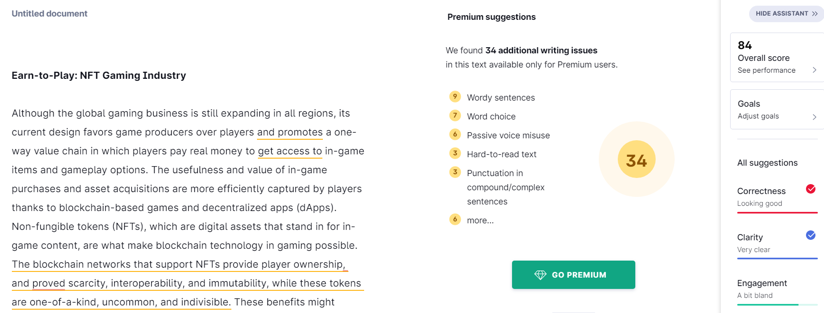

**Plagiarism checker screenshot:**

